Anthony Le

04/13/2021

CECS 229

Section 03

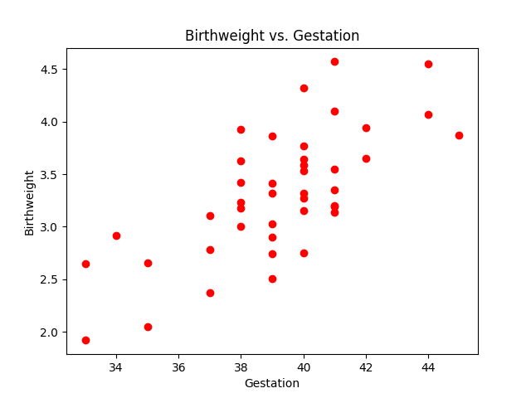Lab 6 Report Findings

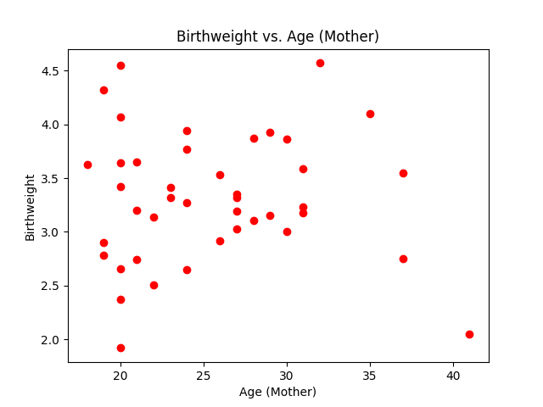**There is a POSITIVE correlation between Gestation and Birthweight**

**There is NO correlation between Age (Mother) and Birthweight**

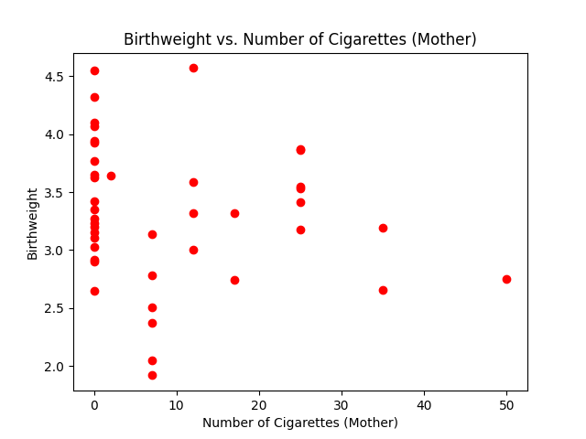

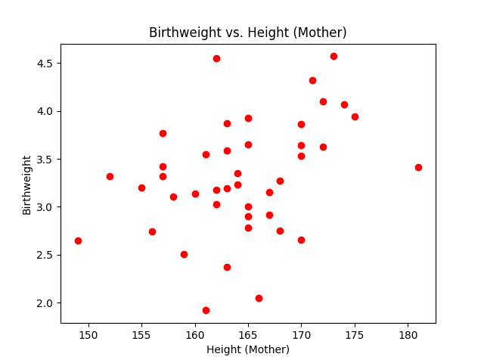**There is a NO correlation between # of Cig. (Mother) and Birthweight**

**There is a POSITIVE correlation between Height (Mother)and Birthweight**

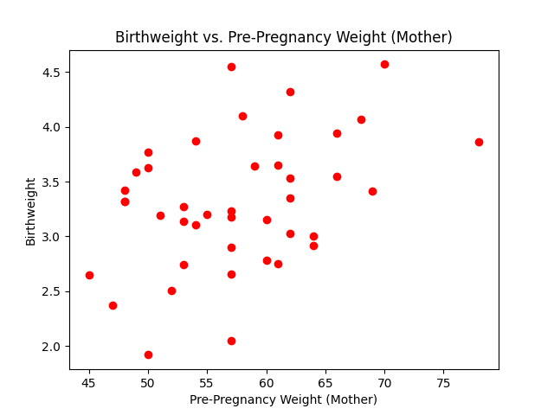**There is a POSITIVE correlation between Pre-Preg. Weight (Mother) and Birthweight**

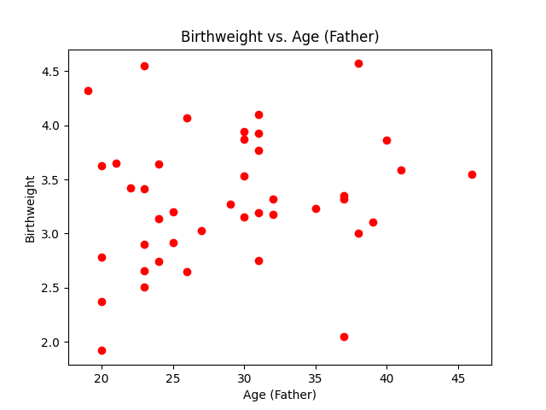

**There is a POSITIVE correlation between Age (Father) and Birthweight**

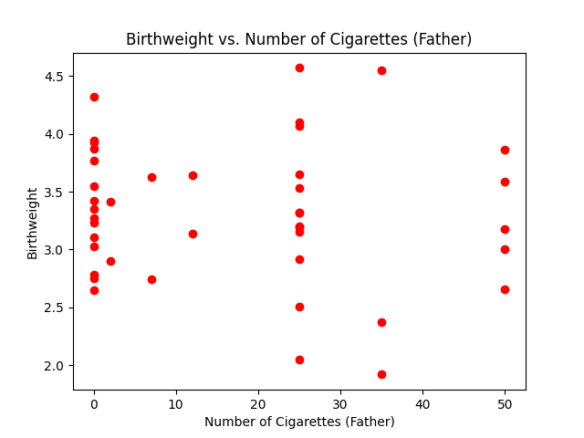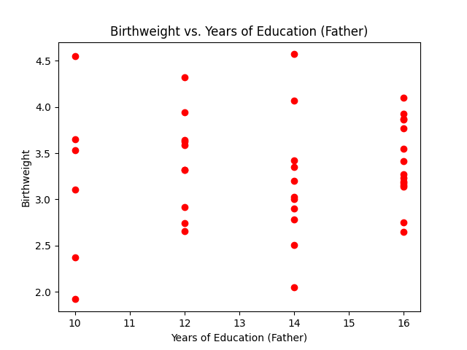**There is NO correlation between Years of Education (Father) and Birthweight**

**There is NO correlation between # of Cig. (Father) and Birthweight**

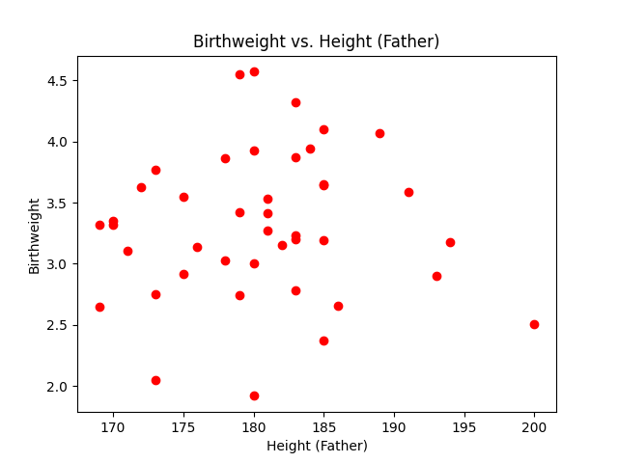

**There is NO correlation between Height (Father) and Birthweight**